About The Lilac Players
The purpose of The Lilac Players is to foster theatrical opportunities for women
and LGBTQIA+ members of the community by producing and promoting staged shows.
We focus on showcasing new productions and re-framing existing works through
nontraditional casting, or performing works which challenge outmoded norms,
celebrate our diverse lifestyles, and entertain audiences throughout.

Board of Directors
President: Emma Brown
Vice President: Anna-Constantia Richardson
Treasurer: Wyn Brown
Secretary: Tyler Crosby
Chairperson of the Board: Meghan Jolliffe
General Board Member: Alison McDonough
STAY IN THE LOOP:
thelilacplayers@gmail.com

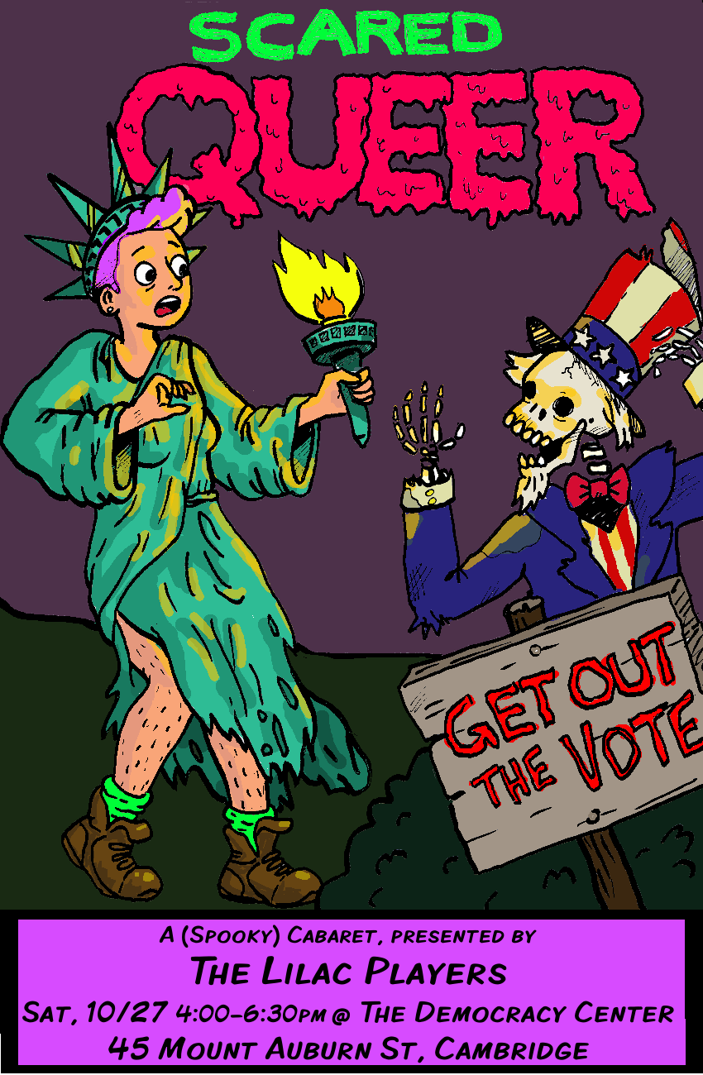

Artistic Director: Emma Brown
Music Director: Julie Henion Richardson
Piano Accompanists: Kelvyn Koning & Paul Gallagher
Guitar: Nick Stevens

PART 1
Murder, Murder…………...………………………….....The Company
Jekyll & Hyde

Take Me to Church………………………………………...Kitty Drexel
Hozier

Deanna………………...……………………………….…....Wyn Brown
Poem by Wyn Brown

Anthem................................................Anna-Constantia Richardson
Chess

Money, Money……….…..Meghan Jolliffe, Kim Dauber, Kitty Drexel
Cabaret

M…………..…..……………………………….……….…....Wyn Brown
Poem by Wyn Brown

Jack’s Lament…………..…………………………….……Kim Dauber
The Nightmare Before Christmas

The Name of Love………………………........Andrea Humez, Anna-
The Mystery of Edwin Drood Constantia Richardson

Pamina’s Aria……………………………………….....Julia Austenfeld
The Magic Flute

Maid of Monsters.…..……………………………….….....Wyn Brown
Poem by Wyn Brown

Mr. November…...…………………………….................Nick Stevens
The National

Why are All the D’ysquiths Dying?……………....... The Company
A Gentleman’s Guide to Love and Murder

~INTERMISSION~

PART 2

Why are All the D’ysquiths Dying? (Reprise)……...…Émile Lewis
A Gentleman’s Guide to Love and Murder

Kiss of the Spider Woman………..….Anna-Constantia Richardson
Kiss of the Spider Woman

Prophecy Girl…….....................................................Meghan Jolliffe
Tiny Fences: A Buffy Podcast

Change……………………………….……...………..…Paul Gallagher
A New Brain

The Curse of Millhaven…………………………………...Émile Lewis
Nick Cave and the Bad Seeds

Dangerous Game……………….........Sara DeLong, Meghan Jolliffe
Jekyll & Hyde

What are You Going to Do, Chop Off My Hands?.......Wyn Brown
Poem by Wyn Brown

Ya Got Trouble………………...………....…...…...…..Andrea Humez
The Music Man

Johanna…………………...….....................................Meghan Jolliffe
Sweeney Todd

Grendel’s Cunt….…..……………………………….….....Wyn Brown
Poem by Wyn Brown

The Vigil……………..…..…………………………….……Kim Dauber
Snoopy! The Musical

Poison in My Pocket………………........Sara DeLong, Nick Stevens
Jekyll & Hyde

Total Eclipse of the Heart……………Nick Stevens, Meghan Joliffe

Thank you so much for joining us today!!

